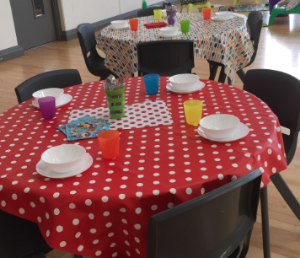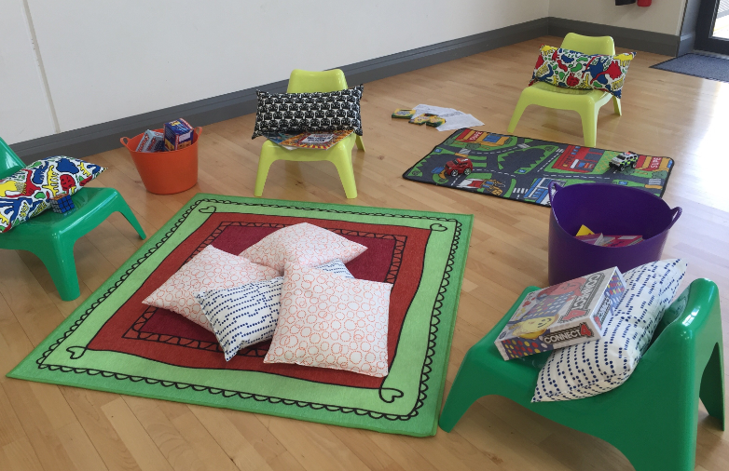

Breakfast Club at Wicklow Educate Together

Breakfast Club at WETNS launched on 11th September 2017 operating in the school hall Monday to Friday from 7:30 a.m. until 8.50am. Breakfast Club is coordinated by Kate Hennessy, Olwyn McHale, and Margarita Nowicka. Our aim is to provide a relaxed and welcoming space for children to enjoy before the school day begins.

Parents are asked to accompany their children into the school hall each day to sign them in. We use the middle entrance to the school to access the Breakfast Club.

Breakfast is served from 7.40am until 8.15am sharp. We serve a healthy breakfast menu, available on our school website. To promote independence the children are encouraged where possible, to serve themselves. After breakfast, we have supervised outdoor play (weather permitting), a relaxing reading corner, drawing/colouring materials and board games, Lego and other toys, giving the children time to relax and socialise with their peers. Please note, our breakfast club is a technology free zone.
Cost is €5.00 per child per day (including breakfast) for regular attendees. €6.00 per child per day for ad hoc attendance. Payment is due on the last Friday of the month for the days attended in that month. You can make payment directly into our extra-curricular bank account by cheque or by cash. IBAN – IE34AIBK93361905417550 BIC – AIBKIE2D

We will run our new breakfast club on a trial basis from early September to end December and if this works well as a successful addition to our extra-curricular programme, we will continue it for the rest of the year. As with all our extra-curricular activities, this club is only open to children attending Wicklow Educate Together N.S. If you have any questions, please do not hesitate to contact us at breakfast.club@wicklowetns.com or contact Lisa Jervis at the school office. Many thanks Lisa, Kate, Olwyn McHale, Margarita

