Our Wicklow Women Exhibition
Last Monday Rebeka, Niamh, Camilla, Molly and I went to the Council buildings for an exhibition on famous Wicklow Women to read out summaries of their lives. I got Anna Parnell, founder of the Ladies Land League, whilst others got the first woman to become a Ship’s Captain, one of the first Irish female Mountaineers, and the founder of British Ballet. Altogether there were 13 women represented. We did a dress rehearsal in an old meeting room, before milling about the exhibition. After a while, two reporters came to take our photos for the newspapers. 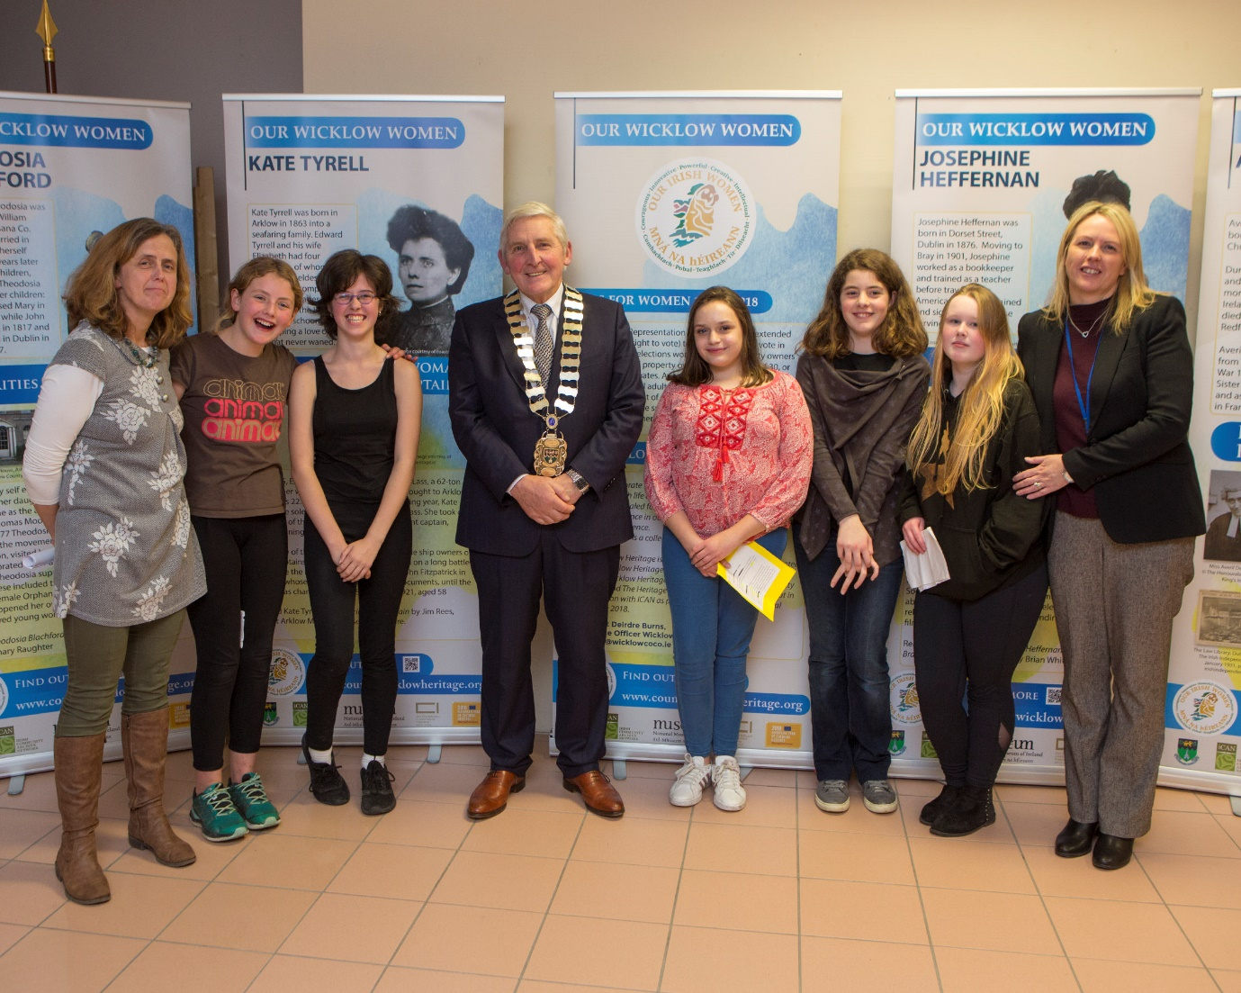
When it was time, we went up to the podium to read our scripts. As there was only five of us, it went by very quickly. After that the Town Councillor read out a speech declaring the exhibition officially open. We all stayed chatting for a bit, then we went home.
The experience was very interesting (and fun) and I would definitely do it again. Holly Lewis 6th Blue

