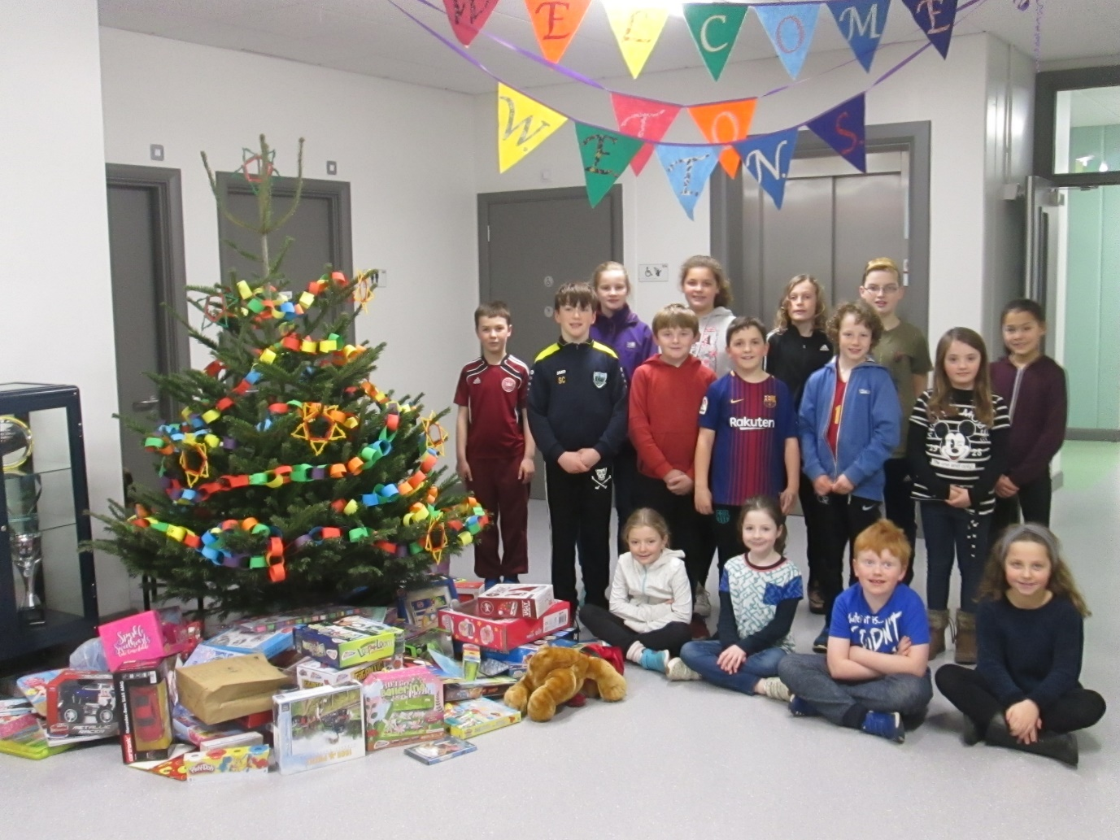

The Student Council would like to say a very big thank you to the entire school community for your very generous response to our Toy Appeal for The Simon Community. The Simon Community works with homeless individuals and families all around the country. The donated toys were collected on Tuesday, December 19th, and will be distributed across the east coast over the coming days. Many thanks again for your wonderful support for a very worthy cause.

